HOUSTON/AUSTIN
Good Neighbor Program
Complete this portion to link your Remarkable Card to the charity of your choice.
You can choose to link up to three charities. Contact your charity of choice and ask if they are a member of our Good Neighbor Program or ask the Courtesy Booth for the GNP number of a particular charity. To learn about the Good Neighbor Program, go to www.randalls.com.

REMARKABLE CARD NUMBER:

Don't know your card number? Call Customer Care at 1-877-723-3929.

Charity to be added to your card:

- Charity # 13111

- Charity #

- Charity #

Charity to be deleted from your card:

- Charity #

- Charity #

- Charity #

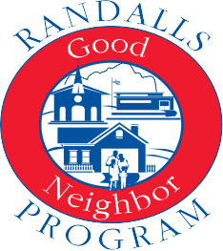

APPLICANT NAME (PLEASE PRINT) PHONE

APPLICANT SIGNATURE DATE

PLEASE RETURN THIS FORM TO YOUR NEIGHBORHOOD RANDALLS COURTESY BOOTH

OFFICE USE ONLY: STORE #
COURTESY BOOTH: SEND THIS COMPLETED FORM TO THE MAILROOM - ATTN: DATA CENTER OF ARIZONA

